Third Announcement of 2026 International Conference on Plant Stem Cell and Regeneration（2026.8.28-31）

About the Conference
Plant stem cells and regeneration constitute the foundation of plant morphogenesis, and the underlying theories have been widely applied in modern biotechnology, including tissue culture, vegetative propagation such as grafting and cuttage, plant genome editing and genetic transformation, molecular breeding, and plant chassis technologies in synthetic biology. These theories also play a pivotal guiding role in industrial applications such as cellular agriculture and vertical farming. To facilitate in-depth exchanges on the frontiers of fundamental theory and applied technologies in plant stem cells and regeneration, and to establish an international academic platform for exploring their prospects for industrial application, two International Conferences on Plant Stem Cells and Regeneration were initiated and held in 2022 and 2024. To further advance this initiative, the 2026 International Conference on Plant Stem Cell and Regeneration will be held from August 28 to 31, 2026 in Weihai City, Shandong Province, China. The Conference is jointly organized by the Shandong University, Huazhong Agricultural University, Chinese Society for Plant Cell Biology, with co-organization by Shandong Kedilian Plant Stem Cell Co., Ltd.
The theme of this conference is “Plant Stem Cells: The Power of Regeneration, the Source of Health.” The conference will focus on key scientific questions and emerging frontiers in the field of plant stem cells and regeneration. It will feature in-depth discussions on fundamental research, technological innovations, and application-oriented explorations. The conference aims to establish a high-level academic exchange platform and to promote innovative development and the training of young researchers in the plant stem cell field. The organizing committee cordially invites experts, scholars, researchers, students, and industry representatives from related fields at home and abroad to participate in the conference and exchange ideas.

Organizations
Host
Shandong University
Huazhong Agricultural University
Chinese Society for Plant Cell Biology
Organizer
School of Life Sciences of Shandong University
College of Life Science and Technology of Huazhong Agricultural University
Co-organizer
Plant Stem Cell Committee of Shandong Province Stem Cell Association
Shandong Kedilian Plant Stem Cell Co., Ltd.
Conference Chairs
Pil Joon Seo Xiansheng Zhang Zhaojun Ding Chunli Chen
Conference Scientific Committee
Luca Comai Henrik Jönsson Ari Pekka Mähönen Pil Joon Seo
Akira Iwase Peter Marhavý Chunming Liu Xiansheng Zhang
Suiwen Hou Yuling Jiao Zhaojun Ding Lin Xu
Chunli Chen
Conference Organizing Committee
Xiansheng Zhang Zhaojun Ding Akira Iwase Ying Wang
Weibing Yang Lin Xu Jianghua Chen Yi Zhang
Chunli Chen Chengyun Zheng Tao Xia Jinkun Liu
Pingping Qian Tingting Xiao Mingchen Zhang Xueyou Cao
Jianhua Bian Xiangpei Kong Yunyuan Xu
Conference Theme
Plant Stem Cells: The Power of Regeneration, the Source of Health
Conference Topics
Comparative Studies of Plant and Animal Stem Cells and Regeneration
Molecular Mechanisms of Plant Stem Cells and Regeneration
Plant Stem Cells and Evolutionary Development
Plant Stem Cells and Synthetic Biology
Plant Regeneration and Transgenic Technologies

Conference Registration
1. Registration Fees
Online Registration (includes conference materials, coffee/tea breaks, and meals during the Conference; travel and accommodation expenses are to be borne by participants)
Before June 15, 2026: Student/Postdocs CNY 500, Regular (Academic) CNY 1000, others CNY 1500
After June 15, 2026: Student/Postdocs CNY 600, Regular (Academic) CNY 1200, others CNY 1800
Category | Early Registration (on or before June 15, 2026) | Late Registration (after June 15, 2026)
Student or Postdoctoral Representative | RMB 500 per person | RMB 600 per person
Regular Representative (Academic) | RMB 1,000 per person | RMB 1,200 per person
Industry Representative | RMB 1,500 per person | RMB 1,800 per person

On-site Registration (includes conference materials, coffee/tea breaks, and meals during the Conference; travel and accommodation expenses are to be borne by participants)
Student/Postdocs CNY 800, Regular (Academic) CNY 1500, others CNY 2000
Category | Fee
Student or Postdoctoral Representative | RMB 800 per person
Regular Representative (Academic) | RMB 1,500 per person
Industry Representative | RMB 2,000 per person
Please note: The early registration deadline is June 15, 2026, at 24:00 (Beijing time) , subject to the timestamp of successful payment of registration fees.

After registration and payment are completed, fees will generally not be refunded. Participants who are unable to attend for valid reasons may request to transfer their registration to another person. The transfer request must be submitted by the original registrant via the conference email address, providing the transferee's name, affiliation, contact information, and other necessary details. The transfer will take effect after confirmation by the conference organizing committee. To facilitate conference arrangements, it is recommended that transfer requests be submitted no later than August 21, 2026.

2.Payment Methods
Please make your payment online through the conference website at plantstemcell2026.org.cn, or by scanning the QR code below：
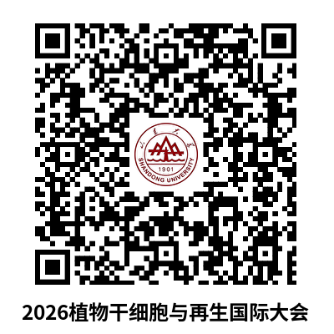
Please note: For Alipay payments, please scan the QR code using Alipay; for WeChat Pay, please scan the QR code using WeChat.

For bank transfer payments, please remit the payment to the following account:
Account Name: Shandong University
Taxpayer Identification Number: 12100000495570303U
Address: No. 72 Binhai Road, Jimo District, Qingdao, Shandong Province, China
Tel: 0532-58630097
Bank: China Construction Bank, Jimo Blue Valley Sub-branch
Account Number: 37150199766500000030
Please be sure to indicate the following in the payment remarks: Name – Affiliation – 2026 International Conference on Plant Stem Cell and Regeneration.
If multiple participants from the same institution make a joint payment, the names of all participants must be provided. If participants are from different institutions, separate registration and payment are recommended.

3.Registration and Abstract/Poster Submission:
Please keep the payment receipt after completing the payment, as it will be required for registration on the conference website and for the submission of abstracts and posters.
The submission website: https://plantstemcell2026.org.cn/abstract/
Abstracts and posters are invited from registered participants. Based on the submitted abstracts and the Conference program, approximately 30 participants will be selected for oral presentations, including short talks (15 min) and flash talks (3 min).
Applicants who wish to present an oral talk must complete registration and payment by August 18, 2026, and submit their abstract and poster materials (if any) through the conference website.
Abstracts must be prepared using the official Conference template.
Poster size: 120 cm (height) × 90 cm (width). The Conference will arrange centralized poster printing and display.
In addition, the conference will offer generous awards for young researchers, including Best Oral Presentation Awards and Best Poster Awards.

4. Invoice Issuance
You may fill in the invoice - related information when making payment via QR code scanning. Please fill in all details accurately and carefully. For questions regarding conference fee payment and invoice issuance for bank transfers, please contact Mr. Xiangpei Kong at Shandong University. Email: kongxiangpei@sdu.edu.cn.

Conference Program
Venue: Weihai Bliss International Hotel , Weihai, Shandong, China
Dates: August 28–31, 2026
Provisional Program:
August 28, Afternoon
Registration
August 29, 8:00–12:00
Academic Session
Opening Remarks
1 | Zhihong Xu | Academician of Chinese Academy of Sciences (CAS)
2 | Kang Chong | Academician of Chinese Academy of Sciences (CAS)
Keynote Lecture
3 | Luca Comai | Member of US National Academy of Sciences; University of California, Davis
4 | Jun Sheng | Former President, Yunnan Agricultural University
5 | Ying Wang | Capital Normal University
6 | Pil Joon Seo | Seoul National University
7 | Chunli Chen | Huazhong Agricultural University
8 | Mulan Zhu | Shanghai Chenshan Botanical Garden
9 | Jinkun Liu | Director of Shandong Engineering Research Center for Plant Stem Cell Technology; Head of Kedilian Plant Cell Industry Platform
Aug 29, 13:00–15:30
Field Visit – On-site tour of the industrialized production base for ginseng stem cell-derived adventitious roots.
August 29, 15:30–18:00
Academic Session
1 | Yunde Zhao | University of California, San Diego
2 | Weibing Yang | Center for Excellence in Molecular Plant Science, CAS
3 | Akira Iwase | RIKEN, Japan
4 | Li Wang | Agricultural Genomics Institute at Shenzhen, Chinese Academy of Agricultural Sciences (CAAS)
5 | Short Talk | Selected from participants
Aug 30, 8:00–10:00
Academic Session
1 | Henrik Jönsson | Director, Sainsbury Laboratory, University of Cambridge
2 | Xiangyu Zhao | Shandong Agricultural University
3 | Yifeng Hou | Peking University Institute of Advanced Agricultural Sciences
4 | Short Talk | Selected from participants
break
Aug 30, 10:00–12:00
Academic Session
5 | Suiwen Hou | Lanzhou University
6 | Peter Marhavý | King Abdullah University of Science and Technology (KAUST), Saudi Arabia
7 | Short Talk | Selected from participants
8 | Flash Talk | Selected from participants
Aug 30, 14:30–18:00
Academic Session
1 | Xiaofeng Gu | Biotechnology Research Institute, CAAS
2 | Mateusz Majda | University of Lausanne, Switzerland
3 | Lin Xu | Center for Excellence in Molecular Plant Science, CAS
4 | Pingping Qian | Lanzhou University
Keynote Lecture
5 | Ari Pekka Mähönen | Finnish Academy Professor, University of Helsinki
Award Ceremony
Outstanding Posters and Outstanding Presentations
Aug 31, Morning
Field Excursion (for botany; pre-registration required)
Aug 31, Afternoon
Departure
Note: A few slots for Short Talks and Flash Talks are still available. Please register before 18:00, August 18, 2026.

Media Partners (more than 100 outlets):
People’s Daily, People’s Daily Online, Xinhua News, CCTV.com, China.org.cn, China Daily Online, China Youth Daily, China Economic Net, Guangming Online, China News Service, CPPCC Daily Online, Xuexi.cn, Global Times, People’s Daily Omnimedia, National Party Media, People’s Livelihood Weekly, People’s Health, etc.
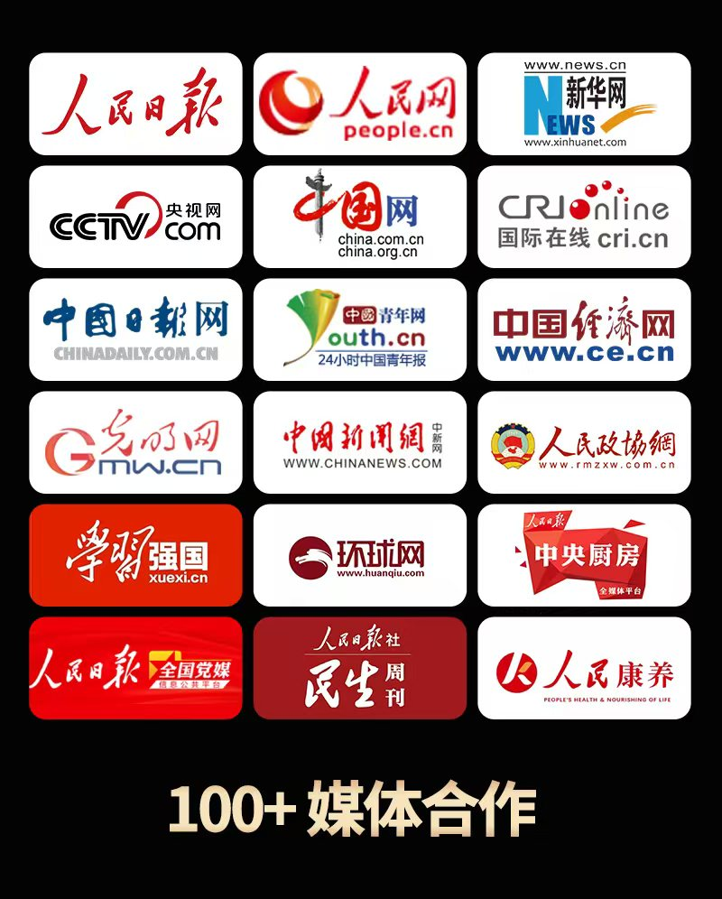

Accommodation and Transportation

1. Hotel Reservation
The conference will reserve hotel rooms for invited speakers. All participants are kindly requested to make their own hotel reservations as early as possible according to their schedules.
During the conference, participants may enjoy a special conference rate of RMB 380 per night for either a King Bed Room or Twin Bed Room, including breakfast for two.
All participants are kindly requested to fill in their hotel accommodation details via the conference website.
- For new registrants: Please directly indicate your check-in date, room type, guest name(s), ID/passport number, and contact phone number in the conference registration form.
Link: https://plantstemcell2026.org.cn/register/
- For those who have already registered and wish to add or modify their hotel information: Please log in to your original registration account and proceed to the “Hotel Information Supplement” page.
Link: https://plantstemcell2026.org.cn/hotel-reservation/

This step is for room reservation purposes only on behalf of the conference organizing committee. No online prepayment is required for your accommodation. All room charges should be settled directly with the hotel upon check-in.
When checking in, please inform the hotel front desk that you are participating in the “2026 International Conference on Plant Stem Cells and Regeneration” and that your room has been pre-blocked by the conference organizing committee.

Weihai Bliss International Hotel (威海铂丽斯国际大酒店)
Address: No. 19 Huanghai Road, Economic and Technological Development Zone, Weihai, Shandong, China (威海市经济技术开发区黄海路19号)
Reservation Tel: +86-0631-5973888
2. Transportation Suggestions
Weihai Railway Station → Weihai Bliss International Hotel
Distance: 2 km; by taxi: approx. 6 minutes.
Weihai Dashuibo International Airport → Weihai Bliss International Hotel
Option 1: Taxi – 34 km, approx. 40 minutes.
Option 2: Airport shuttle bus to Hanlefang Station (approx. 60 minutes), then take a taxi to the hotel (approx. 6 minutes).

Contact Us
Conference Website: plantstemcell2026.org.cn
Visa Inquiry:
Qianyin Jin (Jnqy71@126.com)
Registration, Poster & Abstract Submission:
Youhao Peng (1831027933@qq.com; hj1831027933@gmail.com)
Sponsorship:
Zihan Zhang (1070649515@qq.com)
Payment and Invoice Inquiry:
Xiangpei Kong (kongxiangpei@sdu.edu.cn).
General Conference Email:
plantstemcell@sina.com
If you have any questions, please feel free to contact the conference organizing committee using the contact information provided above.

